|  |
| --- |
| RAIDRIN  Macintosh HD:Users:AldrinJerome:Projects:SlotMachine:company_logo.png |
| PINOY SKATER |
| **Collector in Bohol** |
| Version #1  All work Copyright © 2013 by Raidrin Games.  All rights reserved. |
| **Aldrin Jerome Almacin** |
|  |

|  |
| --- |
| July 8, 2013 |

**Table of Contents**

3 ……………………………………………………………...……………………………………………………….. Version History

6 …………..………………………………………………...……………………………………………………….. Game Overview

6 …………..………………………………………….…...……………………………………………….. Game Play Mechanics

6 …………..……………………………………………………….…...………………….…………………………………….. Camera

6 …………..……………………………………………………….…...……………………………………………………….. Controls

7 …………..……………………………………………………...………………….……………………….………Interface Sketch

7 …………..………………..……………………………………………..………………….. Menu and Screen Descriptions

8 …………..………………..………….……………………………….…...……….………….……………………….. Game world

8 …………..………………..………….……………………………….…...……….………….………………………….. Characters

8 …………..………………..………….……………………………….…...……….………….……………………………... Enemies

8 …………..………………..………….……………………………….…………...……….………….……………………….. Scoring

9 ………………………....…..………………………………………….…...………………….……………………….. Sound Index

9 …………..…..………………………………………….…...………………….……………………….. Art/Multimedia Index

9 …………..…..………………..………………………………….…...………………….……………………….. Future Features

**Version History**

**Jul 09, 2013**

[**Changed names of files**](https://github.com/aldrinalmacin/Pinoy-Skater/commit/2cf4b25ba003a8c885bffe9272a80d2209ba10ae)

**Jul 08, 2013**

[**Finished external documentation**](https://github.com/aldrinalmacin/Pinoy-Skater/commit/3d652c9b57771e2a142a1cc0840a535e6766741d)

[**Finished commenting Skater**](https://github.com/aldrinalmacin/Pinoy-Skater/commit/ffb11eb30f86aea0a8c1a1017ef56c863ed2bf93)

[**Commented Game Action**](https://github.com/aldrinalmacin/Pinoy-Skater/commit/469c49e5c654333be4d0d2524028438b3456ce44)

[**Finished commenting game scene and moving bg**](https://github.com/aldrinalmacin/Pinoy-Skater/commit/a3457d85e40b29952ae04b984005389a5c23a6d1)

**Jul 03, 2013**

[**Started documentation**](https://github.com/aldrinalmacin/Pinoy-Skater/commit/05c8aa5033003f050e7d140de4aa9967f1114964)

[**Sounds added when button clicked and background music changed**](https://github.com/aldrinalmacin/Pinoy-Skater/commit/5c5405d4083c91989aa3c799273eda610354c8ad)

[**Changed filetype of effects to ogg**](https://github.com/aldrinalmacin/Pinoy-Skater/commit/16bcd96141a354e34b7e426436915c0a1e4702ae)

[**Added bg wav back**](https://github.com/aldrinalmacin/Pinoy-Skater/commit/e5773cc349a428d20e17fc4096a5ed1c47a5c061)

[**Deleted bg.wav**](https://github.com/aldrinalmacin/Pinoy-Skater/commit/6c5c6a9d0c38c29726b2d98f37dc97b724d57863)

[**Better Sounds and music added**](https://github.com/aldrinalmacin/Pinoy-Skater/commit/9b81bf92742fc89d23883a1375c56d47d09593f7)

[**Added sounds**](https://github.com/aldrinalmacin/Pinoy-Skater/commit/1ae2024299b40694baaaf46ab797d4cd02edc44d)

[**Added sounds**](https://github.com/aldrinalmacin/Pinoy-Skater/commit/d18d0d237d9e6a6b80526d633c5c614486520ad0)

**Jul 02, 2013**

[**Added button to start game**](https://github.com/aldrinalmacin/Pinoy-Skater/commit/f6a5cf82973ef49c9026616c4eb650a69ca0c4d6)

[**Added Instructions Screen**](https://github.com/aldrinalmacin/Pinoy-Skater/commit/b6ee01404f686b39d44719fea00eff1490ee3d72)

**Jun 29, 2013**

[**Added hit graphic when hit**](https://github.com/aldrinalmacin/Pinoy-Skater/commit/ce678920e23b7814064da3e75d25ef7e9772b375)

[**Changed image for start screen**](https://github.com/aldrinalmacin/Pinoy-Skater/commit/a7bae7e748293612fb056aff5fcc6e851a1d2ca8)

[**Realligned sprites on proper positions**](https://github.com/aldrinalmacin/Pinoy-Skater/commit/634fba6e3dc2f85e8b6a221e51c9fe0ed5eee3e1)

[**Changed Graphics and points of items and obstacles**](https://github.com/aldrinalmacin/Pinoy-Skater/commit/bfcb82316da47c491297b1d410c4906338918d50)

[**Added caption**](https://github.com/aldrinalmacin/Pinoy-Skater/commit/48ed1e133c99b41a8c39c4b733bf28f276d8691b)

[**Final Score bug fix**](https://github.com/aldrinalmacin/Pinoy-Skater/commit/9efdffae5f2d2255c62248ecd52045a550303a62)

[**Game Over Screen Finished**](https://github.com/aldrinalmacin/Pinoy-Skater/commit/6de8751e97df0987bb8a64a56ddfa07b1c948af6)

[**Updated graphics in start page**](https://github.com/aldrinalmacin/Pinoy-Skater/commit/01abd151fbe9156b291f11cd15f245617277d219)

[**Added scorer**](https://github.com/aldrinalmacin/Pinoy-Skater/commit/1f9fe22ff30173bb0debd479f750478e67f77496)

[**Changed the skater's jump height and candy position**](https://github.com/aldrinalmacin/Pinoy-Skater/commit/5a4294bad321b6f5c6573015d10b1c1f8ff7a7df)

[**Score is given when a candy collides with the avatar**](https://github.com/aldrinalmacin/Pinoy-Skater/commit/e3a8e98ca398d05830eaedb49453e956d22a4a2f)

[**Added scoring items in the game**](https://github.com/aldrinalmacin/Pinoy-Skater/commit/870859c6bf1d034b55c7909a6b816328ada39c80)

[**Added mouse control**](https://github.com/aldrinalmacin/Pinoy-Skater/commit/a94f80c9fab5bcdc11a73b4f30158603a1855e56)

[**Reset added**](https://github.com/aldrinalmacin/Pinoy-Skater/commit/f784ffdeb67d8f2b1d42e3ca29d3a0f7ecaecb71)

[**Scenes are now managed in one place**](https://github.com/aldrinalmacin/Pinoy-Skater/commit/8986fc2d96430f952266dfbfd6ae28016022bcef)

[**Fixed bug with count of obstacles**](https://github.com/aldrinalmacin/Pinoy-Skater/commit/4a36b4580159802a6709a13f7ddc2a2e52080168)

[**Added start and game over scenes**](https://github.com/aldrinalmacin/Pinoy-Skater/commit/17038041d1a4438a9b4fdc7ffed7c9e0629afb6b)

**Jun 28, 2013**

[**Speed changes every half minute**](https://github.com/aldrinalmacin/Pinoy-Skater/commit/1e7af92de2e08b2a6f4413c622c18bde745fd2a9)

[**Added LifeHolder**](https://github.com/aldrinalmacin/Pinoy-Skater/commit/46c08a7836b7da9d1c7f0c7ea5d02ead2a21ddeb)

[**Collision bug fixed**](https://github.com/aldrinalmacin/Pinoy-Skater/commit/ea82fcaac02c5c0bf7952bf323f8d655c86989d2)

[**Changed image of Rock obstacle**](https://github.com/aldrinalmacin/Pinoy-Skater/commit/58c08280639678521c017bcf4155f1257015d3bb)

**Jun 28, 2013**

[**Checking collisions**](https://github.com/aldrinalmacin/Pinoy-Skater/commit/4d6e99ea0258b8633a3ff0295020184887e3de22)

[**Selects random object to hit the user**](https://github.com/aldrinalmacin/Pinoy-Skater/commit/bf8faf9fca1515d089519b59b631b9b9ec128b8b)

**Jun 27, 2013**

[**Used Multiplex instead of different images**](https://github.com/aldrinalmacin/Pinoy-Skater/commit/34fe330ef9c7fd7bc99059d1a668e9047aca9ebb)

[**Added obstacles**](https://github.com/aldrinalmacin/Pinoy-Skater/commit/f51cb53d358703f5bf6c4f952253935424674c4b)

[**Added objects to be hit by the skate boarder**](https://github.com/aldrinalmacin/Pinoy-Skater/commit/18a0721ad1b20f0689f1ba91ccc93f606a41652a)

[**Added stone image and movement of skater fixed**](https://github.com/aldrinalmacin/Pinoy-Skater/commit/e7a01952245ad40d1a83a571cd71ba604e4d0ad9)

[**Changed Images to proper ones**](https://github.com/aldrinalmacin/Pinoy-Skater/commit/4cf4eb45767c3e77bb4b8890f5eb045e0d7ab974)

[**Jump and Sitting images**](https://github.com/aldrinalmacin/Pinoy-Skater/commit/70d99b60672baf6eb6effb74bcb2851b4e6db6a8)

[**Added jump and slide**](https://github.com/aldrinalmacin/Pinoy-Skater/commit/879fe9e64d9de743388f21e142e7b757772b5062)

[**Fixed parallax speed**](https://github.com/aldrinalmacin/Pinoy-Skater/commit/67af49c1dd4e6cadb35fa07d0324e02d6539149a)

[**Parallax done**](https://github.com/aldrinalmacin/Pinoy-Skater/commit/82c9e0dd2c5b10c36f0e6e98471c02803948ae7e)

[**Resized Cloud**](https://github.com/aldrinalmacin/Pinoy-Skater/commit/2fcb62e072de5250942468edad5ee24d86c550d4)

**Jun 26, 2013**

[**Resized Road**](https://github.com/aldrinalmacin/Pinoy-Skater/commit/8520acb1dbfa33dbd60915d30f6a61411cd35238)

[**Deleted unneeded images**](https://github.com/aldrinalmacin/Pinoy-Skater/commit/604d3ab199860f2cca9d51d4c6da6cf9208b5e06)

[**Merge branch 'master' of**](https://github.com/aldrinalmacin/Pinoy-Skater/commit/e290f38ea8ff52b017b51e39734c377b0a9dca36)[**https://github.com/aldrinalmacin/Katipunero-…**](https://github.com/aldrinalmacin/Katipunero-Runner)[**…**](https://github.com/aldrinalmacin/Pinoy-Skater/commits/master?page=2)

[**Repaired Parallax**](https://github.com/aldrinalmacin/Pinoy-Skater/commit/05ccb25d8729e2b98d1f69cc4a76e6339252a9e2)

[**Parallax for mountain working**](https://github.com/aldrinalmacin/Pinoy-Skater/commit/64573f2b8235750d07759b1149dcc9034dc314c2)

[**Added 2 mountain images**](https://github.com/aldrinalmacin/Pinoy-Skater/commit/aaceaedb616d3b2870e417aa3f2abc067b691f15)

[**Merge branch 'master' of**](https://github.com/aldrinalmacin/Pinoy-Skater/commit/83acbec72b1e4b4d81941d3a251cfb52a1942e69)[**https://github.com/aldrinalmacin/Katipunero-…**](https://github.com/aldrinalmacin/Katipunero-Runner)[**…**](https://github.com/aldrinalmacin/Pinoy-Skater/commits/master?page=2)

[**Changed Width of Graphics**](https://github.com/aldrinalmacin/Pinoy-Skater/commit/218d8e355d46aafd012c9e0c8472973ed0edea44)

[**Changed Graphics**](https://github.com/aldrinalmacin/Pinoy-Skater/commit/35e490a239435c8331040dd7fa2ca113d62b73a4)

[**Reformat call to hero action**](https://github.com/aldrinalmacin/Pinoy-Skater/commit/c56e86c90b5e1257861c5c457c1641cf025d91d0)

[**Converted magic numbers**](https://github.com/aldrinalmacin/Pinoy-Skater/commit/c8da15198cb645b2650be88810cf78020db8af78)

**Jun 25, 2013**

[**Added jump image**](https://github.com/aldrinalmacin/Pinoy-Skater/commit/909693eac4119a462694bda709643fe4fe16de03)

[**Added animations**](https://github.com/aldrinalmacin/Pinoy-Skater/commit/a6d3dc895bdd566fc9dfdd55c5dbcad8720374a3)

[**Movement of hero when down is implemented**](https://github.com/aldrinalmacin/Pinoy-Skater/commit/a47b394c7317e76b7ebf8725dd69999c1ac50e67)

[**Jump bug fixed**](https://github.com/aldrinalmacin/Pinoy-Skater/commit/09112e16e92099a63102bc9204088600a188f6aa)

[**Hero now jumping**](https://github.com/aldrinalmacin/Pinoy-Skater/commit/959155b20cb75a991360e70ab3b322dc8678e042)

**Jun 24, 2013**

[**Added Hero**](https://github.com/aldrinalmacin/Pinoy-Skater/commit/63ae9a3e89e06a2796ef7d0f3bffaf72e82bffe9)

[**Removed system outs**](https://github.com/aldrinalmacin/Pinoy-Skater/commit/4b7c3b2ccc1c7ab7e7fd1dfb5075dc01dd80aebd)

**Jun 23, 2013**

[**Added Parallax**](https://github.com/aldrinalmacin/Pinoy-Skater/commit/60cbc3ed5cdac19f7fe38c09f72df63023072cdb)

[**Parallaxed**](https://github.com/aldrinalmacin/Pinoy-Skater/commit/973f0cb40af465749b52801025bc360d3a483e57)

**Jun 22, 2013**

[**Fake parallax. Need more research on ScrollManager and ScrollLayer**](https://github.com/aldrinalmacin/Pinoy-Skater/commit/b4d3c56c3962e04c5140f81ec467aab58ef94a4f)

[**Added non moving parallax**](https://github.com/aldrinalmacin/Pinoy-Skater/commit/ab170adf6d8367948d4a62468af8fa462914edda)

[**Added scenes module and start game file. Background is in the main scene**](https://github.com/aldrinalmacin/Pinoy-Skater/commit/14bcd5bfa00dad30fd3c2f2c716b479073725936)

**Jun 22, 2013**

[**Started Project**](https://github.com/aldrinalmacin/Pinoy-Skater/commit/e2a8db2374baf879f6e3a7666cee76501ae50a07)

1. **Game Overview**

*This is a normal adventure game where you control a character to gain points while avoiding obstacles to stay alive. By jumping and sitting, you will be able to avoid the obstacles. You have three lives to start the game and each life will be lost after making contact with an obstacle. Get as much points as possible and have fun.*

1. **Game Play Mechanics**

*Get as many points as possible by getting candies and coins. Candies give more points than coins. All candies can be found in the air. Get them by jumping using either the W key on the keyboard or putting the mouse cursor above the avatar. All the coins are found on the ground and they are obtained by running over them. There are obstacles in the game that you have to avoid in order to stay alive. These obstacles are the birds and the rocks. The birds are avoided by sitting down while the rocks are avoided by jumping. You only have three lives in the game and you lose one every time you make contact with any of these obstacles.*

1. **Camera**

*The game is played in side view where it is easier to see the obstacles and the points.*

1. **Controls**

*You can either use the mouse or the keyboard. Use the W key on the keyboard to jump and use the S key on the keyboard to sit down. This will help you stay alive in the game. The mouse is used in the same manner by putting the cursor above the avatar to jump and putting the cursor below the avatar to sit. By putting the mouse on the middle of the avatar, the character goes back in its normal position.*

1. **Interface Sketch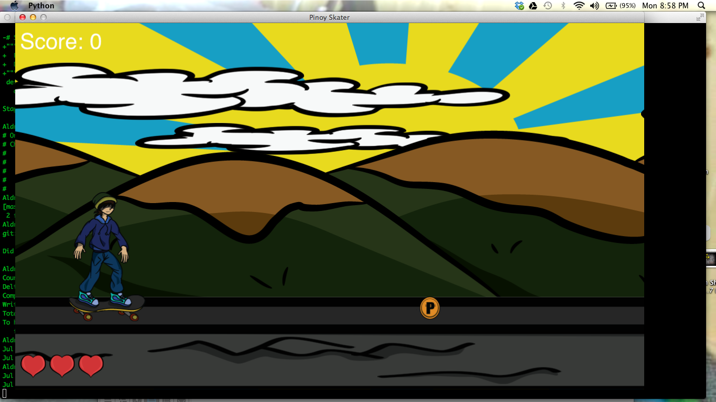**
2. **Menu and Screen Descriptions**

**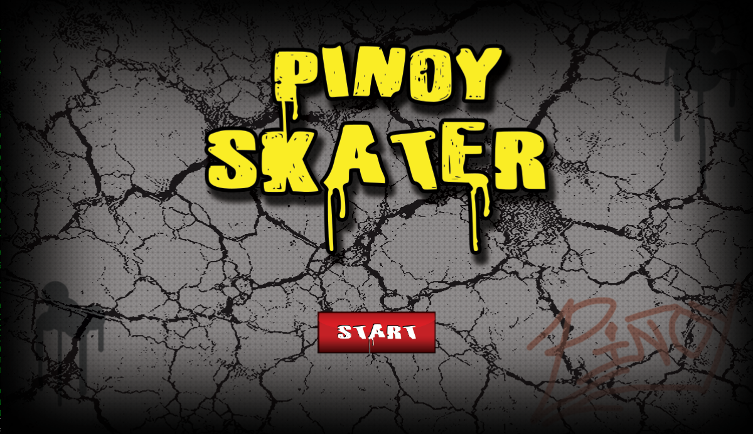**

This is the start screen. This screen contains the start button.

**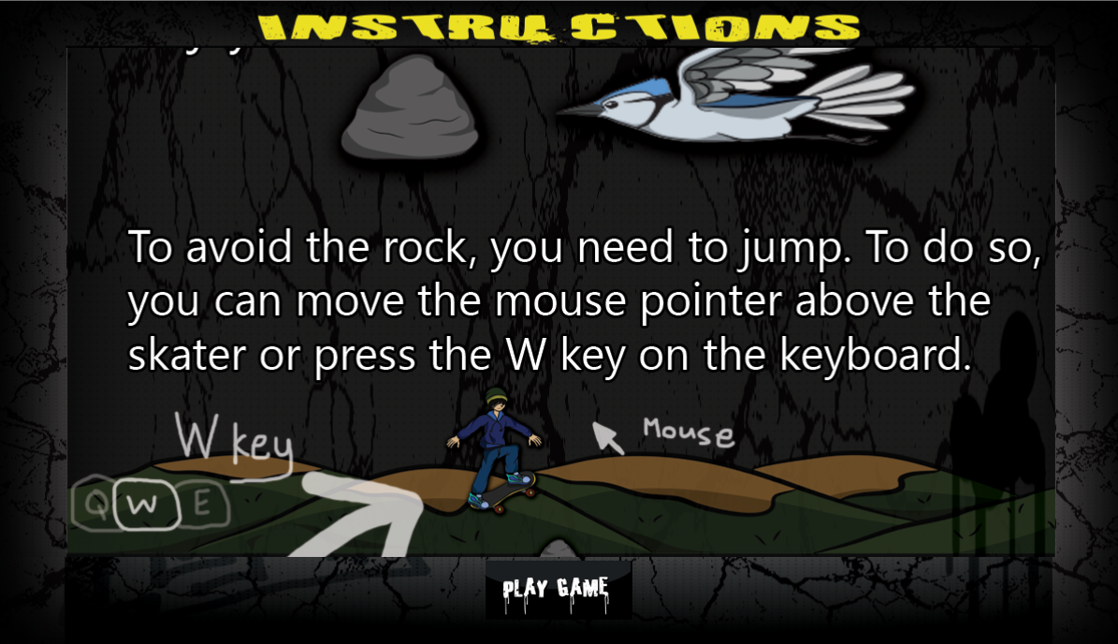**

This is the instruction screen. It teaches the player the main controls before playing

**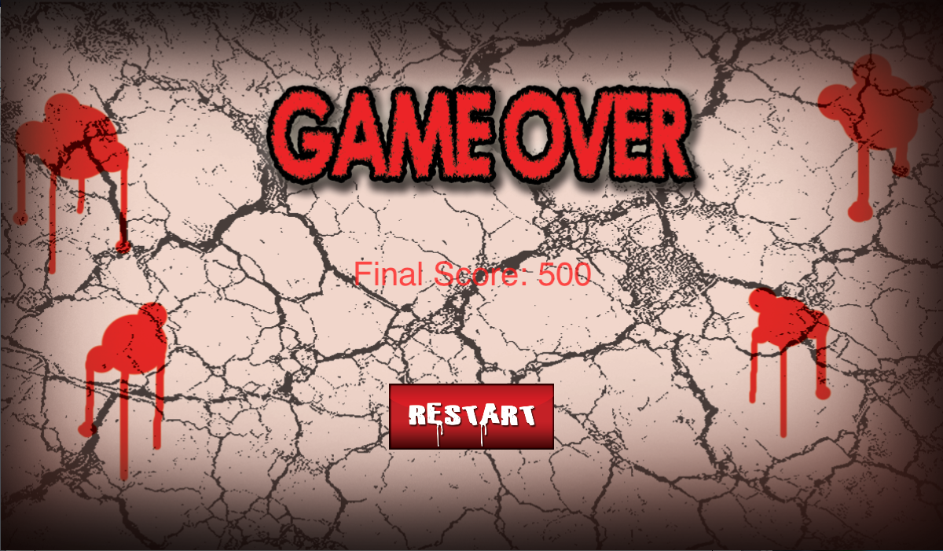**

This is the game over screen. This screen shows the final score and the restart button

1. **Game World**

*The game contains a nice environment with mountains and sunshine. Birds and rocks can be found throughout the game. The avatar is cruising on cement with rocky texture and coins and candies can be found in the game.*

1. **Characters**

*Main Character - The avatar is wearing modern day skater apparel with the dark blue hoodies, blue jeans, green and yellow bonnet, and light coloured skater shoes. The avatar is also cruising on a dark skateboard with red wheels.*

1. **Enemies**

*There are birds and rocks that will act as obstacles in the game. The birds can be avoided by dodging them by while the rocks can be avoided by jumping on them.*

1. **Scoring**

*You get points by getting candies on the air and coins on the floor. Candies gives you more points than the coins due to additional difficulty.*

1. **Sound Index**

|  |  |
| --- | --- |
| **Name** | **Destination** |
| When candy is obtained | sounds/candy.ogg |
| Sound of mouse click | sounds/clicked\_button.ogg |
| Sound of coins | sounds/coin\_pickup.ogg |
| Avatar scream | sounds/gameover.ogg |
| Contact with obstacles | sounds/ouch.ogg |

1. **Art / Multimedia Index**

|  |  |
| --- | --- |
| **Name** | **Destination** |
| Bird obstacle | Images/Bird.png |
| Candy | Images/Candy.png |
| Clouds | Images/clouds\_01.png & images/clouds\_02.png |
| Coins | Images/Coin.png |
| Game Over Screen | Images/GameOverScreenImage.png |
| Heart | Images/Heart.png |
| Hit by obstacle | Images/Hit.png |
| Instructions screen | Images/Instructions.png |
| Mountains | Images/Mountains\_01 &  images/Mountains\_02 |
| Sunshine | Images/NonMovingBG.png |
| Restart Button | Images/RestartButton.png |
| Road | Images/Road\_01.png &  images/Road\_02.png |
| Rock | Images/Rock.png |
| Skater Standing | Images/Skater.png |
| Skater Jumping | Images/SkaterJump.png |
| Skater Sitting | Images/SkaterSitting.png |
| Start Button | Images/StartButton.png |
| Start Screen | Images/StartScreenImage.png |

1. **Future Features**

*Levels*

*Special Items*

*High Score/Database to keep the scores*